Q1. “A conservative is a man with two perfectly good legs who, however, has never learned how to walk forward”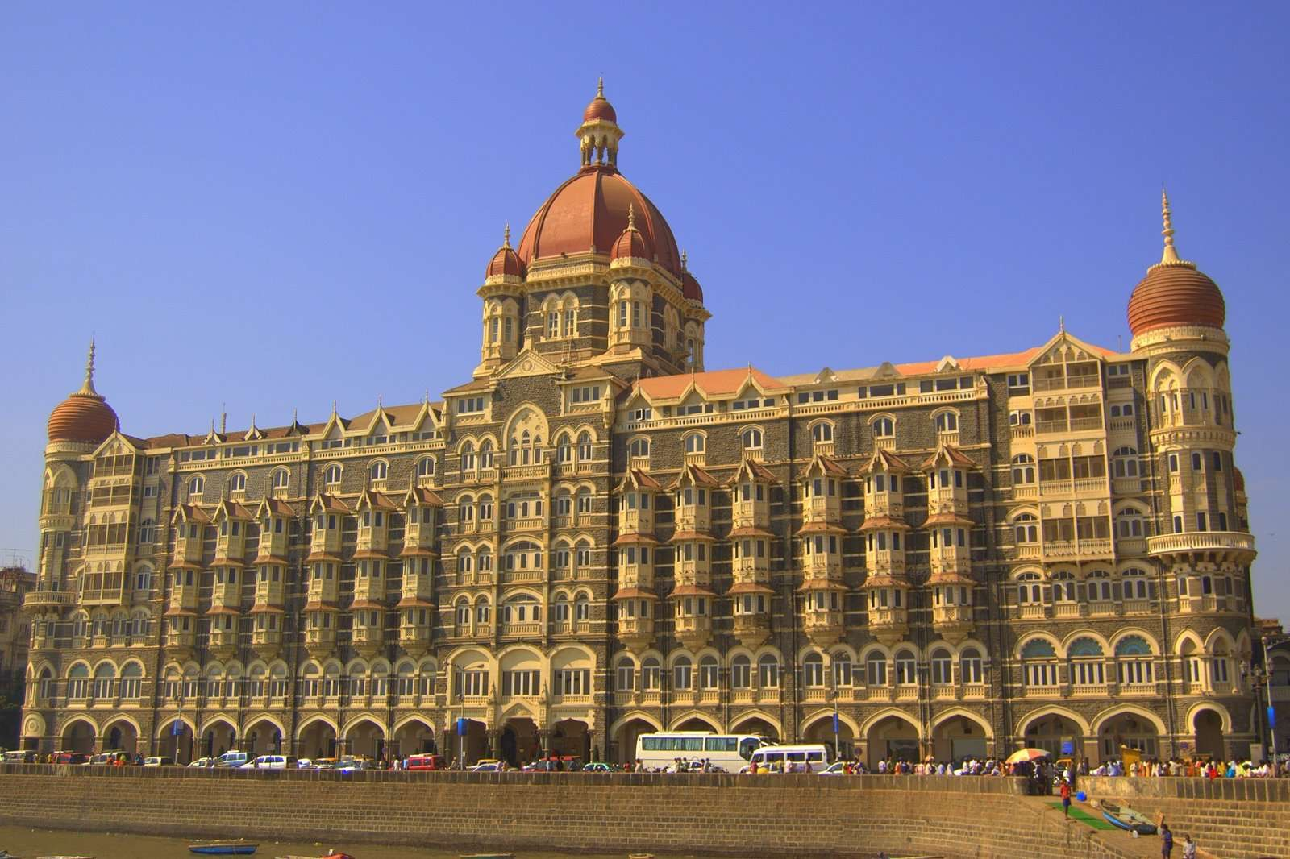

Hotel is your key.

Ans — Waldorf Astoria Hotel

Q2. I am a band.

Ans - Sanam

Q3. I am a hero of ancient past.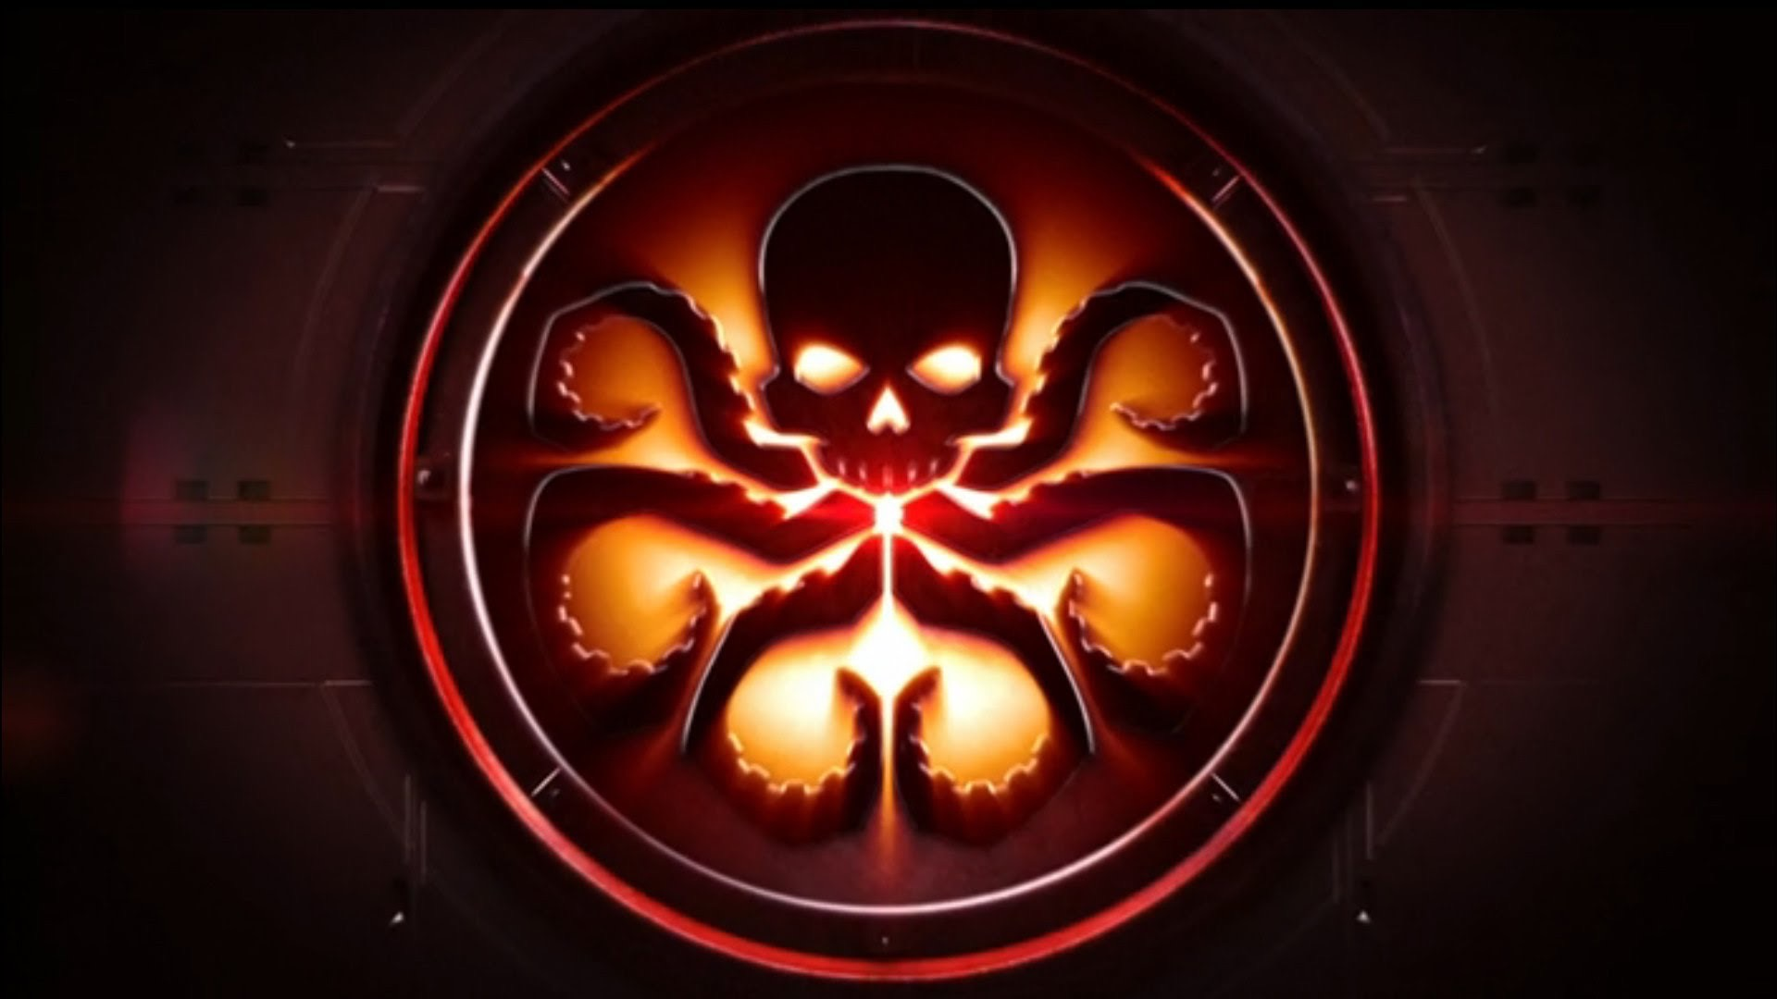

Ans- Hercules

Q4. Dar ke aaghe jeet hai !!

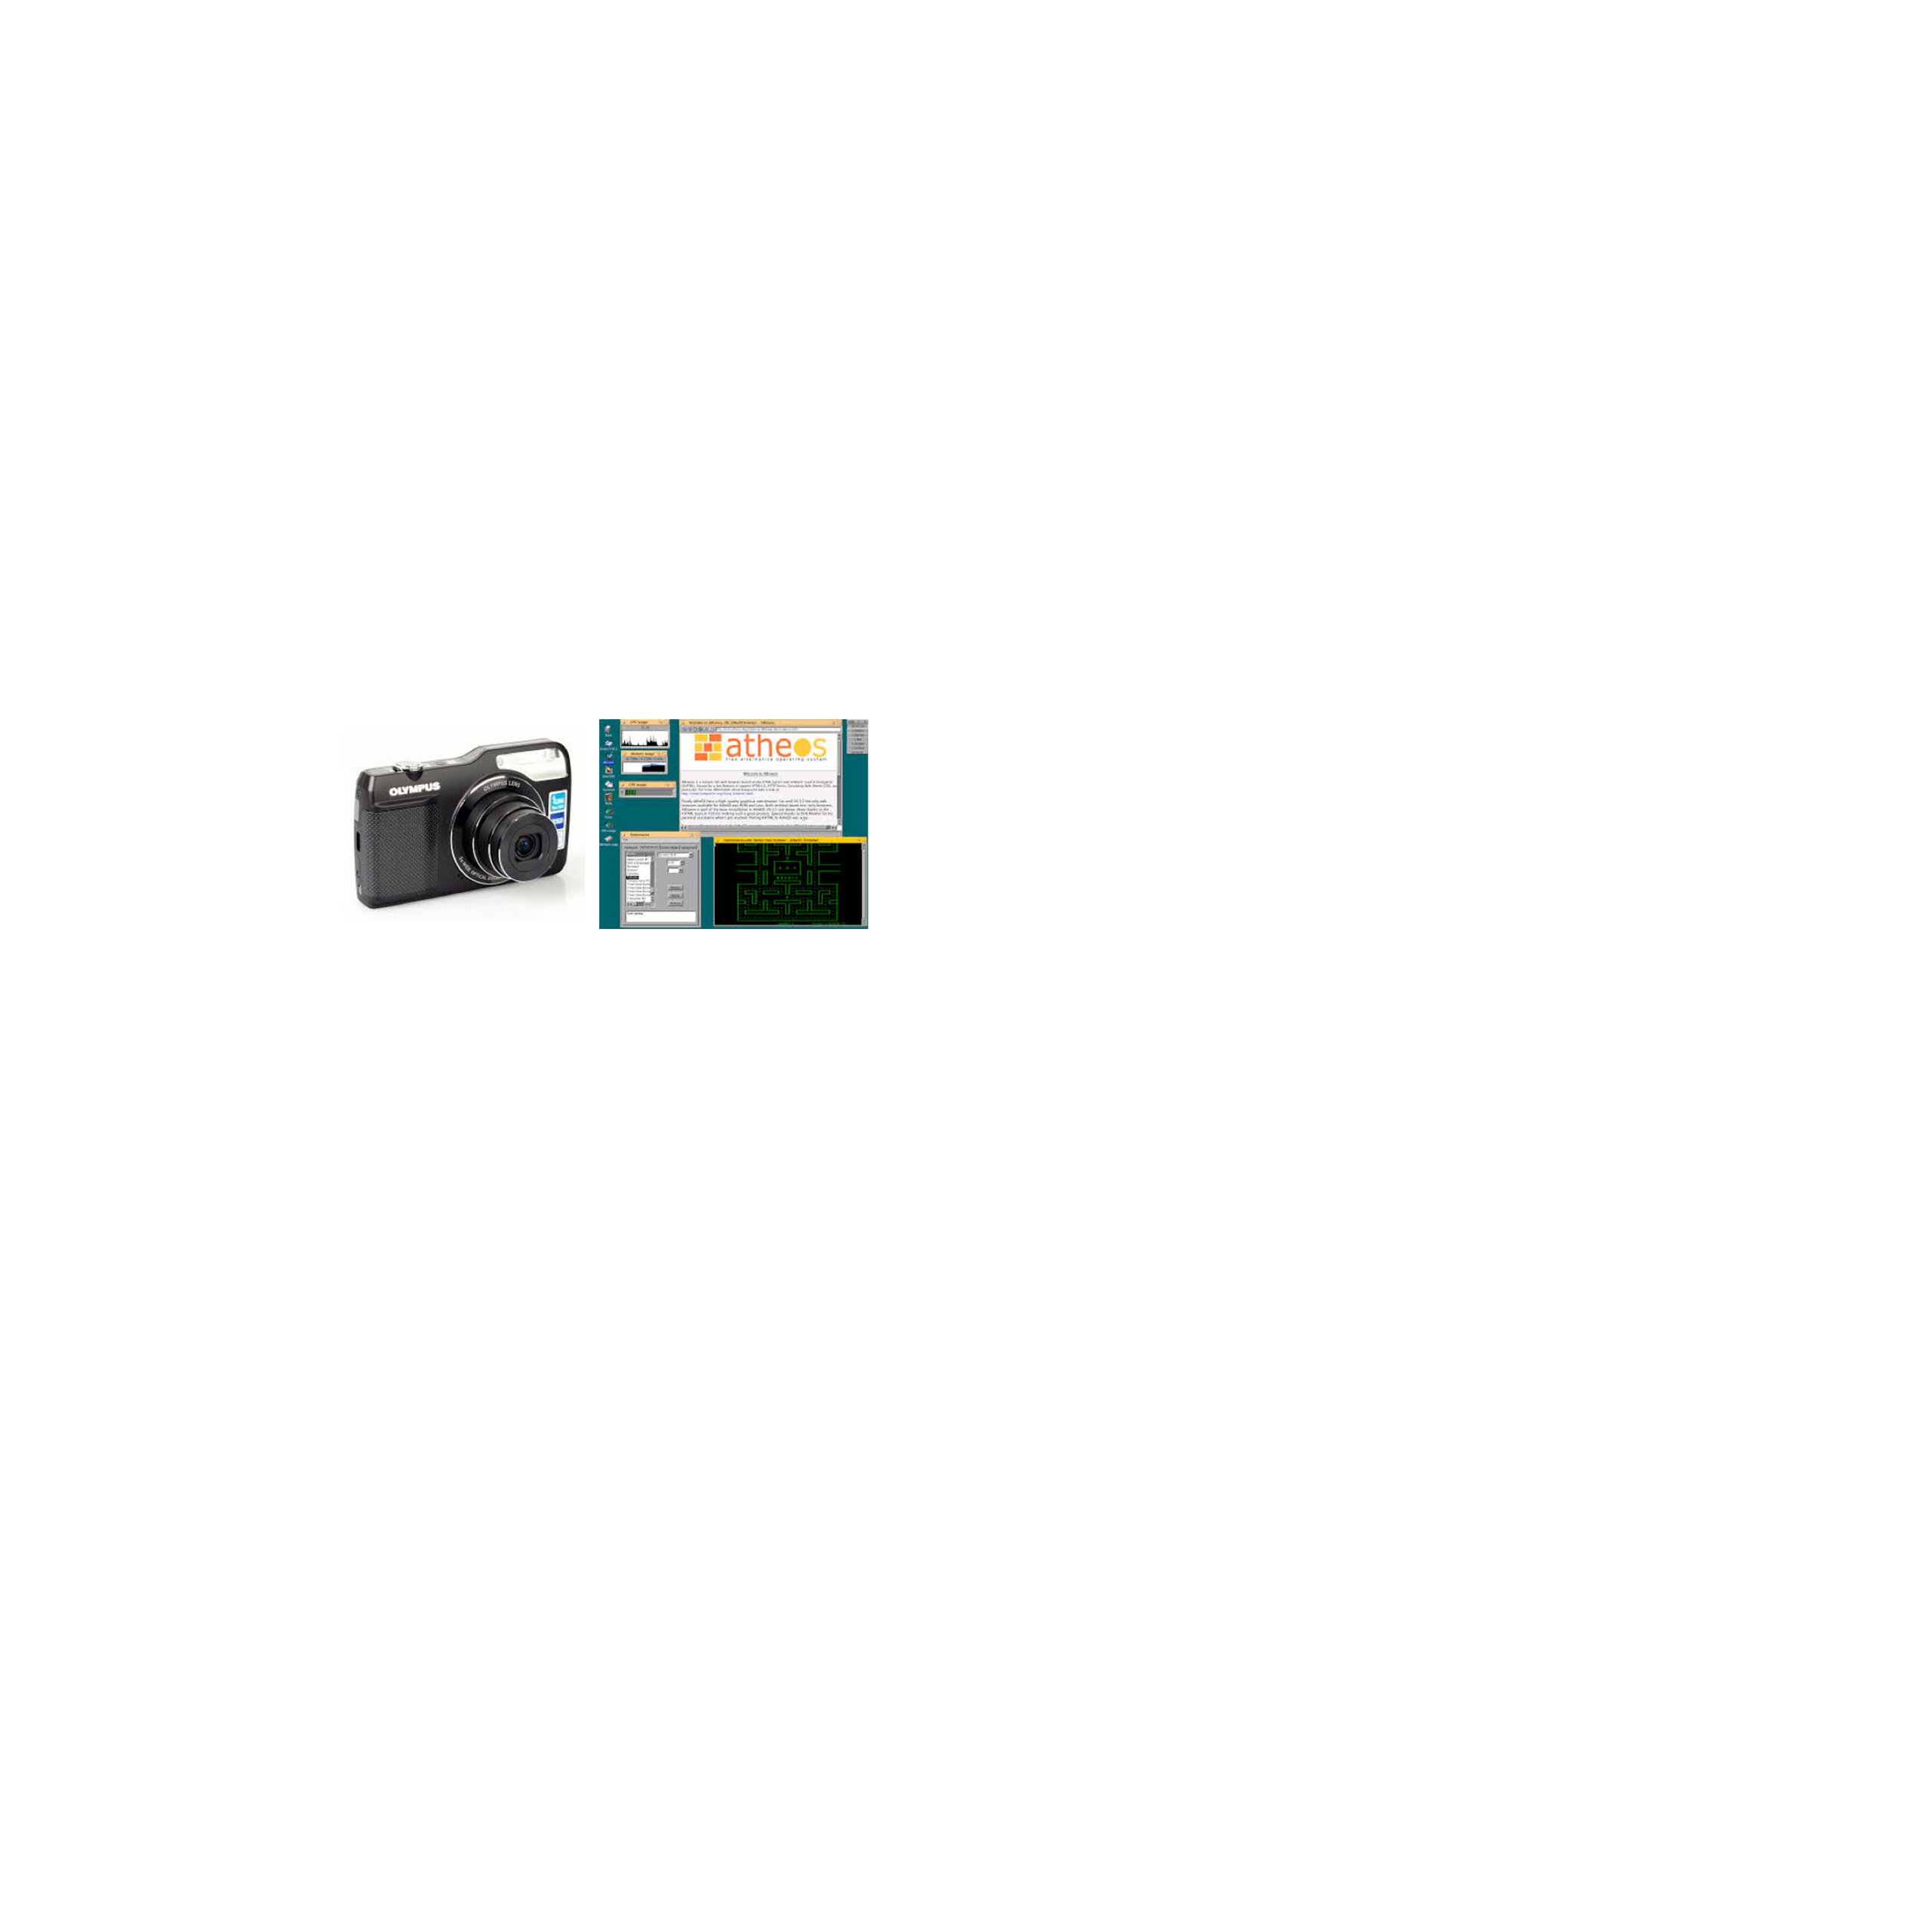

I lie in between and yield powers to the sea.

Ans: Trident, Poseidon’s Trident.

Q 4.What, where did you say??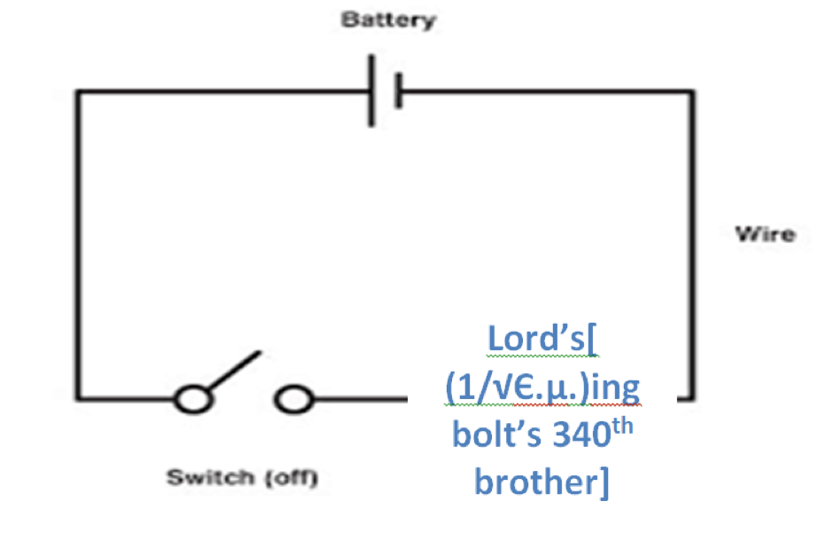

Ans: Coomera QLD, Australia.